Retention Policy

You can set the retention policies for Teams team conversations and chat messages.

**Microsoft Teams retention policies are available in Office 365 security and compliance center**

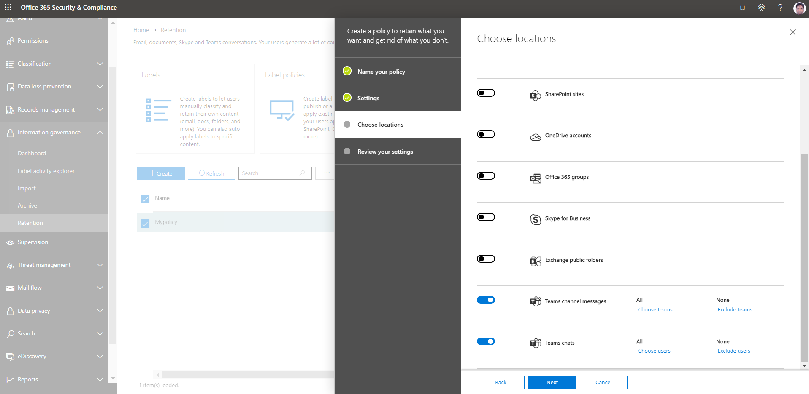

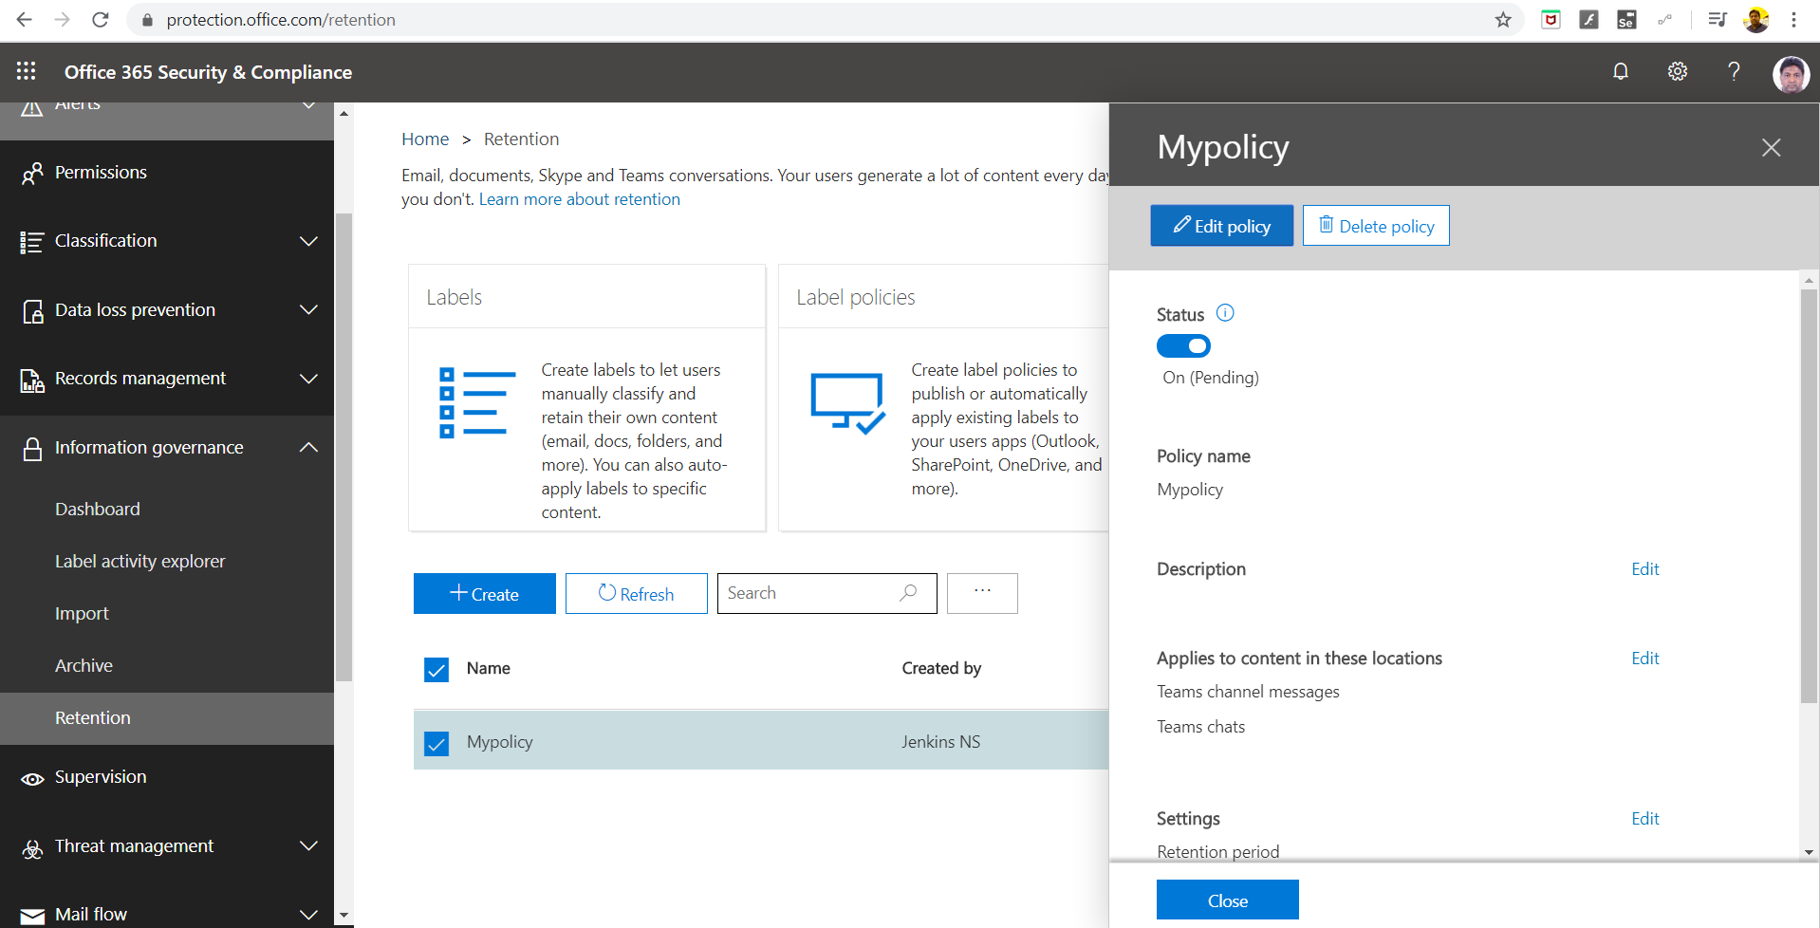

**What are retention policies for Teams?**

For most organizations, the volume and complexity of their data is increasing daily – email, documents, Teams messages, and more. To manage or govern this information is important for admins need to:

* Comply proactively with industry regulations and internal policies that require organizations to retain content for a minimum period – for example, the Sarbanes-Oxley Act might require you to retain certain types of content for seven years.
* Reduce their risk in the event of litigation or a security breach by permanently deleting old content that organizations are no longer required to keep.
* Help organizations share knowledge effectively and be more agile by ensuring that their users work only with content that’s current and relevant to them.

With a Teams retention policy, you can:

* Decide proactively whether to retain content, delete content, or both – retain and then delete the content based on time.
* Use the SCC Policy creation user experience or Teams Retention PowerShell cmdlets
* Set different retention durations for Teams Chats v/s Teams Channel Messages.
* Target the entire organization with these location rows and target specific users (for Teams chat retention) and specific Teams (For Teams channel message retention)
* Use retention policies with the SharePoint & OneDrive location rows to address the Files in Teams.

**Note:** Remember that in Teams, file shared in private chats are stored in the sender’s OneDrive for Business account and files uploaded in a channel conversation are stored in the team’s SharePoint site